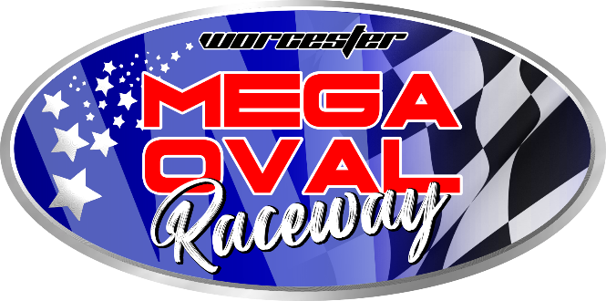

MEGA OVAL
ANTIDOPING CODE

Mega Oval do not condone the ingestion, injection, inhalation or consumption by any means whatsoever of any prohibited substance by any competitor and/or official, either before or during any motor sport event.

Alcohol is not permitted in any officially marked designated “alcohol free area” with specific reference to the Oval Arena and Pit area.

A competitor or Official’s consumption of alcohol is deemed to be excessive should the breathalyzer testing system reflect the presence of alcohol in excess of 0.01gm %.

The Promoters, chief steward or COC of Mega Oval are hereby entitled to randomly select or select by way of ballot papers, any participating competitor / guardian / pitmac or official, or any competitor or official under reasonable suspicion, to test such competitor / guardian / pitmac by or official by way of standard breathalyzer test.

A positive alcohol test, refusal of a competitor or official to undergo a breathalyzer test, or the failure of a competitor being immediately disqualified from the event.

A competitor / guardian / pitmac or official who test positive for alcohol for the first time will be disqualified from the event, will be issued a warning and will lose all points obtained in the event on that day. A second offence will result in suspension for all club events for a period of three months, and a third offence shall result in suspension from all club events for a period of twelve months.

I, _____________________ have read and understood MEGA OVAL’s ANTI DOPING CODE.

_______________ _______________
SIGNATURE DATE

MEGA OVAL

ACKNOWLEDGEMENT AND AGREEMENT BY THE DRIVER

I, as member of Mega Oval, and/or competitor / guardian or official partaking in any motorsport event / meeting at Mega Oval, hereby agree as follows:

- I have received and had an opportunity to review Mega Oval Anti Doping Code, which outline the basic conditions of the use of prohibited substances in accordance with the WADA Anti Doping Code.

- I hereby consent and agree to abide by, comply with, and be bound by all the rules, regulations and conditions imposed by the Promoters of Mega Oval and the WADA Anti Doping Code.

- I acknowledge and agree that the Promoters of Mega Oval have the jurisdiction to impose sanctions as provided for in the Mega Oval Anti Doping Code.

- I acknowledge and agree that any dispute arising out of a decision made pursuant to Mega Oval Anti Doping Code, may be appealed exclusively as provide in Mega Oval Anti Doping Code to an appellate body.

- I acknowledge and agree that the decision of the appellate body referenced above shall be considered final and enforceable and that I will not bring any claim, lawsuit or litigation in any other court or tribunal.

- I hereby acknowledge that I have read and understood the contents of this agreement and acknowledgement and consider the contents hereof as binding.

__________________________ ____________________
Print full name and surname Identity Number

_____________________ ____________________
Signature Date
(if a minor signature of Guardian)

MEGA OVAL
AANSLUITINGSVORM

Naam & Van: _________________________________________________________

Hoofklub: ________________________ 2de klub _________________________

Posadres: _________________________________________________________

Tel: (h) _______________ (w) ______________ (sel) ____________________

Faks: ___________________ Epos: ________________________________

Naasbestaande: __________________________Kontak nr: ______________________

Klas deelname: vul deelname nommer langs klas in.

Stockrod: W____ Hotrod: W____ Midget A-Klas: W____ 1660: W____

H/Metal: W____ 2.1: W____ V8: W____ 4Cyl Contact: W____

Jnr Dev.: W____ Midget B-Klas: W____ Mega Carts: W____ Lexus: W____

Drywer: _______________________ ID: _________________________

Pitmac: _______________________ ID: _________________________

Pitmac: _______________________ ID: _________________________

Ek aanvaar om my neer te lê aan die klub se reëls.

GETEKEN te WORCESTER op hede die _____ dag van _______________ 20_____

Bankbesonderhede:
Mega Oval
FNB, Worcester
Rek no: 62898036093
Takkode: 200 407
Verw: Naam & Van

Lidmaatskap fooie: R400.00 Kwit. No: ____________ Datum: ____________

